National Guard Executive Directors Association

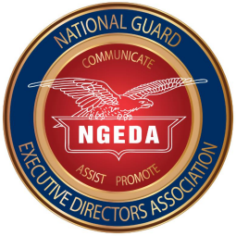
NGAUS CONFERENCE USER GUIDE FOR EXECUTIVE DIRECTORS
January 2026
NGAUS CONFERENCE USER GUIDE
FOR EXECUTIVE DIRECTORS

TABLE OF CONTENTS
Page
Introduction 4
Preliminary Procedures and Information Phase 4
NGEDA Conference 4
Hotel Visits 4
Host State Responsibilities 5
Hotel Selection 5
Following the NGEDA Conference 6 NGAUS Conference Registration 6 NGAUS Resolutions 6 NGAUS Awards Program 6 Official NGAUS Conference Call Letter 6 Officer Development Program (ODP) 6 By-Laws Changes 7 Administrative Leave Requests 7
Executive Director as POC 7

Preparation Phase 7
Conference Requirements 7
NGAUS Annual Dues 7
Registration 7 Registration Refunds 8 Registration Reimbursement 8 Hotel Room Reservations 8 Hotel Room Deposit Refunds 8 Software Registration Cut-off Date 8 Registration Packet Pick-up 8
Delegate Selection 8

Added Options
Publicize State Registration 9
Trading Pins 10
Hospitality Room 10
Apparel 10
Rental Vehicle 10
Staff 11
Officer Professional Development (OPD) Mentor 11
Hotel Coordination 11
Hospitality Night Event 11
Administrative Items 11
Conference Guide 11
Sponsorship Letter 11
Photographs 11
Delegate Contact List 12
Conference Phase 12
Prior to Attendee Arrival 12
Hotel Coordination Meeting 12
Hotel Check-In 12
On Site Registration 12
On Site Membership 13
Conference Administrative Areas 13
Post Attendee Arrival 13
Executive Director Role 13
Host State Welcome Couple 13
Hospitality Room 14
Hotel Check Out 14
Hotel Cancellations 14
Transportation 14
After Conference Phase 14
NGAUS Points of Contact 15
Attachments
1. NGAUS Hotel Selection Checklist 16
2. Hospitality Room Sample Floorplans 17-19
3. Sample Daily News 20
4. Sample Menu 21
3. Hospitality Room Sponsorship Letter 22
4. NGAUS Conference Registration Form 23-24
5. Corporate Partner Interaction 25-27

NGAUS CONFERENCE USER GUIDE
FOR EXECUTIVE DIRECTORS
INTRODUCTION
This guide is offered by the National Guard Executive Directors Association (NGEDA) to assist association Executive Directors (ED) in coordinating and overseeing their association’s participation in the National Guard Association of the United States (NGAUS) annual general conference. Use of this guide is strictly voluntary and does not presume to offer a complete or better solution for an effective and successful NGAUS conference than policies currently used by the associations.
This guide captures helpful hints and suggestions that have proven successful for some in the planning and execution of their association’s attendance at the NGAUS conference.
PRELIMINARY PROCEDURES AND INFORMATION PHASE (JANUARY – MAY)
There are a number of requirements to be accomplished by the Executive Director to ensure that his/her association has an enjoyable and rewarding NGAUS conference experience. The first phase begins at the NGEDA conference and ends after returning home from the conference.
- NGEDA CONFERENCE. Traditionally convened during the month of January, and conducted at the site of the upcoming NGAUS conference and starts the planning for that year’s event. Executive Directors will interact and discuss ideas with other ED’s, association officers, NGAUS staff, and corporate entities in attendance. The NGEDA board of directors is responsible for selecting the hotel in the host city to conduct the Annual NGEDA Conference. The following preliminary guidelines are suggested:

a. Hotel Information. The host state will provide hotel information to each state and territory at least two weeks prior to the NGEDA conference. This information will include, but not be limited to, the following:
- A map of all hotel locations and distance to the convention center.
- The number of sleeping rooms in each hotel to include room rates.
- The number of suites at each hotel to include square footage and room rates.
- Cost for vehicle self-parking and valet.

b. Hotel Visits. Host State (HS) Planning Committee will schedule hotel visits to those hotels they have contracted with for sleeping rooms and hospitality suites for the NGAUS Conference. Rates for sleeping rooms and hospitality suites have already been determined by the HS Housing Committee. Be aware, there may be additional fees such as state and city taxes, resort fees, parking fees, over and above the room rate. The HS will use a 4-year history of “requested” and “used” rooms when contracting hotel room blocks for each state. The HS should contract for a variety of suite sizes as depicted in the attached example floor plans for small, medium, and large suites. The hotel selection checklist on page 15 may be helpful in selecting the hotel for your state delegation, note pads, smart phones and cameras may be of help as you try to remember each hotel and various room layouts. HS will have already made arrangements with each hotel pertaining to allowing food and beverages to be brought into your hospitality room.
c. Host State Responsibilities. The HS will be responsible for setting up three (3) rooms which will be used for the hotel selection process. The HS staff will work with the NGAUS Housing Bureau (SPARGO) and the hotel AV staff to ensure these set-up requirements are met.
- Staging Room: this room or a dedicated space is established for state representatives to see an overview of the hotel inventory status. This space will include a large flat screen TV with a live-feed to the hotel room/suite inventory, a flat screen TV showing which state is making their hotel selection and which state is on deck and provide tables and chairs for state representatives.
- Selection Room: this room will be staffed with HS Housing Committee, NGEDA Room Representative, and representatives from SPARGO. In this room each state will select their hotel and the number of rooms in the block based on their 4-year history of usage. The state may also select only one hospitality suite. Additional suites may be requested after all states/territories have completed their initial hotel room/suite selection. This room will include a flat screen TV with a live feed to the hotel room/suite inventory, and sufficient tables and chairs for support staff. Each state will receive a written receipt listing their hotel, number of sleeping rooms, and suite name, if a suite is selected.
- Contracting Room: this room the Executive Director or designated state representative will pay a deposit for their room block which is currently $100/sleeping room and $200/hospitality suite. Payment can be made with a check or credit card as determined by the HS. Each state will receive a paper receipt for their payment. The HS has the option of holding a state’s room block with an association credit card and not collecting a room deposit which eliminates the need to reimburse funds to the states after the NGAUS Conference.
d. Hotel Selection. After your hotel visits, the process begins with the selection of your hotel usually the next morning. The HS, the shadow HS, and the NGAUS room/suite blocks shall be removed from the hotel blocks prior to the hotel lottery. Each state will be scheduled a time to visit the Host State Rooming Committee based on your lottery number from the previous year’s NGEDA Conference. The HS will set-up a large flat screen TV in the NGEDA meeting room for the benefit of State EDs to know which state is selecting their hotel and which state is on deck based on the hotel lottery for that year. The HS may also consider a “live feed” link for the convenience of allowing state reps to monitor the hotel selection inventory from a phone, iPad or laptop. Prior to your assigned time, you will have the opportunity to review the available inventory of remaining rooms and suites. NGEDA uses a four (4) year rolling average of rooms requested and used in the four (4) previous NGAUS Conferences. Each state, territory and DC will be provided a copy of their four (4) year averages prior to the NGEDA Conference. Those numbers are strictly used as guidelines for each state, territory and DC. Any deviations of these numbers will be determined by the HS Rooming Chairman. Each state, territory and DC will be provided a form for selecting their hotel, number of sleeping rooms and hospitality room by name and number, place in order top three (3) hotels. If more than three hotels are available, you may select more than three in priority order. Any additional request for items for your hospitality room need be mentioned on the selection sheet, i.e., second attached bedroom if available, just make sure you know what you are requesting. Information will be provided if paying by check who to make the check out to, and if they can except credit cards. All payments are due when you reserve your sleeping and hospitality rooms. Once your hotel selection is confirmed, at your convenience, return to that hotel and meet the appropriate staff you will be working with to coordinate your stay. States and territories are not permitted to go “off the grid” and negotiate additional rooms and/or suites with their assigned hotel without first coordinating with the HS Rooming Chairman. Suggest meeting with the director of sales or catering/banquet and room service director to coordinate food and drink for your hospitality room. Exchange business cards to help when it is time for direct coordination.
2. FOLLOWING THE NGEDA CONFERENCE. Additional information from NGAUS will be provided to the states following the NGEDA conference. You may be answering NGAUS conference email and meeting early conference deadlines concurrently with your own state association conference preparation and execution.
a. NGAUS Conference Registration. In February, the NGAUS registration committee will provide (1) the official NGAUS conference registration program software via e-mail, (2) a registration and housing instruction letter listing hard deadline dates that must be met using the registration program software, and (3) a sample conference registration form that you will modify to fit your state association circumstances. The modified registration form will allow your association members to register for the conference through you. You will collect the monies and registration forms in your state and provide that information via the official conference software program and send it in electronically. Note that some events cost extra, and you will want to recover the $100 room deposits you paid at the NGEDA conference, so be sure to collect all monies required. Your registration form should include payment method options and deadline date for return of completed forms to you. You may want to show the total actual hotel room charge, including room tax/resort fee, as opposed to the basic room rate. You also have the option to add a line on your registration form assessing a small fee to each of your state delegates to help offset the cost for food and beverage in your hospitality suite. Make the registration form as user-friendly as possible. Finally, print copies of all your registration reports and bring those to the NGAUS conference.
b. NGAUS Resolutions. You should receive e-mail from NGAUS headquarters in the April timeframe reminding you that the deadline to submit proposed resolutions to NGAUS is 1 July.
c. NGAUS Awards Program. You should receive information about the NGAUS awards program in the October timeframe. The deadline for NGAUS award nominations is 15 February. The NGAUS website Awards link lists all of the awards and the nomination criteria. The NGAUS awards program POC is Mr. Rich Arnold, 202-454-5301 or richard.arnold@ngaus.org.
d. Official Conference Call Letter. You will receive the official call of the NGAUS General Conference from the NGAUS president in the May timeframe. You should print, read and keep that information handy. In addition, visit the NGAUS website often for updated information concerning the conference, especially the conference schedule of events that provides information about the day-to-day activities.
e. Officer Development Program (ODP). Your state Adjutant General should receive information from NGB in the May timeframe concerning the officer development program (OPD). NGAUS has been asked to provide a copy of that information to association Executive Directors as well; however, if you do not receive that, request a copy from your Adjutant General or contact NGAUS and ask for the information. Again, that information should arrive in May; however, it is sometimes later and does not allow much time to disseminate the information and receive nominations of officers to attend the NGAUS conference to participate in the program.
f. By-Laws Changes. All proposed by-laws changes are due at NGAUS the first week of June each year. The NGAUS by-laws point of contact is listed on Page 16 under Points of Contact.
g. Administrative Leave Requests. In accordance with your state’s human resources office (HRO) directives, NGB administrative leave/permissive TDY for full time technician/AGR personnel may be granted to members attending as delegates to the NGAUS conference.
h. Executive Director as POC. As Executive Director, you are the main point of contact (POC) for conference attendees from your state. However, you may delegate certain POC responsibilities to others to reduce your workload. Questions will arise prior to and during the conference that your members will expect you to answer or know where to get the answers. It may be helpful to make a folder or three ring binder for all preliminary information and future data. That will give you a one stop location for information to answer inquiries and remind you of what you have coordinated. We are now well into June, and you can really start putting your own special signature on your association’s participation at the conference. Your imagination and of course, your budget, will determine how much you can provide for the enjoyment of your state’s delegation.

NGAUS CONFERENCE REGISTRATION SOP
PREPARATION PHASE
(JUNE TO CONFERENCE TIME)

There are still deadlines to meet, particularly registration and hotel room reservations as well
as hotel room deposit refund dates. Also, there is still time to consider some rewarding
options to make participation at the conference a great experience for your members.
Detailed below are the remaining requirements and some ideas that can be added to the
conference experience. You will have to determine if the extras are affordable and whether
you are willing to put forth the effort to provide them.
- Conference Requirements. There are some very important deadlines that you do not want to overlook; those dates are normally in the June-July-August timeframe. Refer to the NGAUS registration and housing instruction letter for those deadlines.
a. NGAUS Annual Dues. All state and territories are required to pay NGAUS State Annual Dues upon receipt of the invoice and no later than the National Conference for the state’s delegation to be credentialed. Invoices are issued in January by NGAUS to the State Adjutant General, with a copy sent to the State Executive Director. The amount invoiced is based on the assigned officer and enlisted strength of each state as of 30 September of the preceding year. The current rate is $0.25 per person.
b. Registration. Ensure you comply with the NGAUS conference registration final
submission date, which is normally end-of-July/beginning of August timeframe. The
Housing Bureau (registration software portal) will provide a registration link with log in
and password information to each state association. The registration software will require
that the officer is a current NGAUS member with your state. You can register the officer
(and guest/guests) at the same time or add the guest at a later date. The registration
software will ask for address/cell phone/email, arrival & departure dates, mode of
transportation, events (Governor’s reception, banquet, spouse’s reception, golf outing, 5K
run). You also will indicate if the NGAUS member will be a delegate, resolutions chair,
Task Force chair, OPD attendee, shuttle reservations. The registration software also allows
you to preview the registration badges. While NGAUS will provide a suspense date for
registrations, that date will only apply to those registration badges which will be pre-
printed. Officers can still register after the deadline or at the NGAUS conference,
however, their registration badges will be printed on-site. The registration software allows
you send email confirmation to the registered officer. The software also allows you
to send an updated group confirmation to the group POC so that you have an updated list
on a regular basis. Officers can be registered for the conference without making a hotel
reservation.
c. Registration Refunds. The registration software will allow you to cancel a reservation
without penalty up to a specified date, which is provided in the instruction letter.
Registrations cancelled after a specific date will incur a nominal administrative
cancellation fee. If the cancellation is due to mission requirements, reach out to NGAUS
requesting that the cancellation fee be waived; if approved, NGAUS will notify the
software registration company. There may also be a date at which point registration
fees will be non-refundable.
d. Registration Reimbursement.
NGAUS will reimburse each state $180 for advertising the NGAUS conference (using
the NGAUS conference logo for that year) on their website or in newsletters. States must
request reimbursement and provide proof of advertisement to NGAUS.

1. NGAUS will reimburse the registration for each state for award winners or Task Force Chairs. States must request reimbursement. All reimbursements will be actioned by NGAUS Finance Department after the Conference.
e. Hotel Room Reservations. The registration software has two parts – the conference registration and the hotel reservation. Officers can be registered for either part separately or registered for both. At the NGEDA conference, each state committed to a specific number of sleeping rooms (and hospitality suite). Each state has until the suspense date to make changes within their room block in the registration software program. Names must be assigned to each room, even if that means that rooms within your block do not have a conference attendee assigned to it. You may need to assign multiple rooms to yourself or another conference attendee; those names can be adjusted. Or, those extra rooms can be ultimately cancelled. Each state will need to determine if they want to hold hotel rooms for late registrants. You might also want to reach out to other states who are looking for last minute rooms. Even after the registration portal deadline passes, you can still make reservation adjustments (names & dates) directly with the hotel. If you need additional hotel rooms, your first choice should be to contact the HS Housing Chairman. Another option is to contact other State EDs who are in your hotel to see if they have extra rooms they were planning to turn back in to the HS.
f. Hotel Room Deposit Refunds. The NGAUS instruction letter will contain a cutoff date for hotel refunds. No refunds will be made after the cutoff date. However, check with the hotel concerning its cancellation policy; you may be able to recover the deposit from the hotel.
g. Software Registration Cut-off Date. Unfortunately, at a certain point (1-3 weeks before the conference) you will no longer have access to the software registration portal, so it is important to that you print off regular registration and hotel room updates.
h. Registration Packet Pick-up. Each state must make an appointment to pick up their registration packets (including name tags) via the software registration portal.
i. Conference Delegate Selection.
1. Each state and territory is authorized to send delegates to the NGAUS Conference.
The number of delegates is based on your authorized NGAUS membership each year
as of 30 June. NGAUS will provide each state/territory with your delegate counts by
mid-July.
2.State Delegates - each state/territory is authorized the following voting delegates:
- One delegate being the Adjutant General or his/her designated representative.
- One delegate for each 50 NGAUS members, or a major fraction thereof, of the paid Active-Annual, Active-Life (including Digital Active Life), Separated-Annual, and Retired Life members.
- One delegate who is a Retired-Life member.
- Two Company Grade Officer, one Army and one Air.
- One Warrant Officer (any rank).
- Each member of the NGAUS Board of Directors, with the exception of the Adjutant General (ie, if one of your members serves on the NGAUS Board of Directors, their delegate slot will be added to your association allotment).
3.NGAUS Committees – committee members must be chosen from among the
state/territory accredited delegates. A delegate may serve on multiple committees. Each
state/territory is allotted the following slots on committees that meet during the NGAUS
General Conference.
- Committee on Nominations – one member, either Army or Air.
- Committee on Resolutions – two or three members, one member Army, one member Air, and an optional third member for Joint resolutions (the third member may be Army or Air).
4.Caucuses – Caucus members must be selected from among the state/territory accredited
delegates. Delegates may represent their state/territory at multiple caucuses provided
they meet eligibility requirements. Each state/territory is allotted the following slots for
caucus purposes:
- Area Caucus – one member Army and one member Air.
- Company Grade Caucus – one member Army and one member Air.
- Retired Life Caucus – one member Army and one member Air.
- Warrant Officer – one member, any rank.
5.Delegate Votes – it is important to remember that a state delegate who is casting one vote
at a committee or caucus meeting is actually casting multiple votes based on the number
of state delegates attending the conference (if a state is authorized 30 delegates, but only
28 delegates attend the conference, then that state is casting 28 votes not 30 votes). As
an example, if State A has 30 delegates attending the conference, then that state is
casting 30 votes with their one vote. If State B has 20 delegates attending the
conference, then their one vote is casting 20 votes.
6.Remarks – some committees will only allow the accredited delegate named by the
state/territory to attend the committee meeting and vote. Please ensure that whoever you
assign to serve as a committee delegate is available to attend the committee meetings
during the conference to ensure that you don’t lose your voting rights. When Area
Caucuses hold elections, the accredited representatives (Army or Air) must be present to
cast a vote on behalf of your state/territory. It is each state association’s responsibility to
ensure that the named delegates for the Area Caucuses are in attendance during the
Caucus to vote.

Added Options. The following options are offered for your information and suggest ideas for
a smoother process and added bonuses. You can, however, still execute a great NGAUS
conference for your members without these extras.
- Publicize State Registration. You developed your state registration form during the preliminary phase; now you need to get that information to your members. This can be done in a number of ways, to include:
* Use the National Guard electronic bulletin board or similar publication in your state to announce the NGAUS conference
* Place information posters with National Guard units
* Send invitations to specific individuals, especially retirees and those that have attended past conferences
* Send information to administrative officers at NG units (including
copies of the registration form)
* Promote the conference at meetings with National Guard personnel
* Request announcements be made at unit training assemblies
* Update the association website, Facebook, etc., with conference information
to include a copy of the registration form
b. Trading Pins. Most states have lapel trading pins made each year that highlight their state. You can develop your state pin yourself or you might want to form a committee to do this. The pins might feature a specific theme or highlight something unique that identifies and emphasizes your state. Some examples of pins that have been used in past
years are various motor vehicle pins by Michigan and Wizard of Oz characters by Kansas; and the Arkansas pin usually portrays a razorback hog for the University of Arkansas Razorbacks football team. Everybody enjoys trading the pins with other states, and some even try to collect all fifty-four pins during the conference.
c. Hospitality Room. Hosting a hospitality suite/room within your assigned hotel is always an added treat for your delegation. It provides a focal point for your people to meet, relax and enjoy themselves. It also allows you to showcase your state to visitors who stop by. It provides a place for your association delegates to meet to discuss items of concern/interest. If you do not secure a large enough suite during the hotel selection process at NGEDA, consider renting a hotel meeting room to serve as your hospitality suite. Whatever you can provide in the way of refreshment is always appreciated. Since lunch is provided by NGAUS in the convention center many states simply provide light snacks and drinks to stay within budget. States with larger budgets may offer breakfast during the conference for their delegates. If you have a specific theme for your state, the hospitality room is a great place to decorate and add more enjoyment for your delegation and visitors. It is a good idea to have someone in the hospitality room at all times to meet and greet visitors. Another avenue to consider is to combine with another state in the same hotel and share the cost of a hospitality room.
d. Apparel. Providing matching shirts, caps, vests, etc., to your delegation is an extra way to thank them for supporting the conference and shows unity among your delegates at conference functions. Following the conference, those items become souvenirs of the event. Depending on your budget, your association can donate the apparel or charge your attendees for this option.
e. Rental Vehicle. Although shuttle buses are usually provided by the host state to and from the airport and hotel on the assigned arrival and departure days and to/from the convention center during the conference, a rental vehicle is always an asset. They can be used for trips to local vendors in order to stock and replenish your hospitality room at a more affordable price than buying on site. You can add a VIP touch for individuals needing a ride to the airport on days those shuttles do not run. And, by all means you will want to assist your adjutant general and other general officers with this option to accommodate their schedules. If someone needs transportation for non-emergency medical treatment, this will save time. You may want to transport VIPs or corporate members to a local restaurant for a special meal/event.
f. Staff. If possible, enlist someone to help you. There are times when you need to attend meetings or entertain certain individuals. If you have at least one person to work the hospitality room, you will have time to accomplish your duties as ED. You may be able to use officers attending the OPD program by scheduling them to work in your hospitality
room when not attending the OPD sessions.

g. OPD Mentor. Arrange for a responsible senior officer within your state delegation to oversee the OPD program junior officers. The junior officers are usually first-time attendees at the NGAUS conference and require guidance to help them with the OPD requirements and to understand their schedule of events and the functions they should attend.
h. Hotel Coordination. Contact your hotel prior to arrival to confirm the rooms reserved for your attendees and any banquet event orders (BEO’s) or purchases for your hospitality room. The start date that allows direct coordination with the hotel is provided in the registration and housing instruction letter.
i. Hospitality Night Event. This is an awesome evening that can be hosted in your own hospitality room or moved to another location. You can save money by joining with other states for a combined event unique to your group. One combined group of ten states within the Southeast Conference (SEC) has hosted a SEC hospitality night event for the past few years. Planning for that can be initiated during the NGEDA conference and every effort made to find a location, obtain information, and decide on a lead state. Final preparations can be accomplished prior to the NGAUS conference to ensure everything is
set for the big event.
j. Administrative Items. Bring items such as blank checks to pay registration and appropriate fees, a small cork bulletin board or dry eraser board for posting important information, post-it notes, pens, tape, thumbtacks, paper and envelopes. A first aid kit is a good idea. Your attendees will appreciate your thoughtfulness and concern. Do not forget your NGAUS conference planning binder.
k. Conference Guide. An economic asset that will be helpful to your state delegation is an abridged informational pamphlet. Prepared in advance, this guide provides a quick reference that captures each day’s conference meetings, events, etc., showing what, when, and where events are taking place. It can also show reminders concerning appropriate attire and information about your hospitality room. If you will serve meals in your hospitality room, the guide can include menus and serving times. See Attachment 2 for a sample guide.
l. Sponsorship Letters. You might want to develop a letter requesting financial contributions to support your association’s attendance at the NGAUS conference. Establish a list of businesses and individuals in your state that might assist you with a donation. You will be pleasantly surprised by the result of this effort. Donations received can be used to help offset your hospitality room expenses or sponsor a particular junior officer. Include a self-addressed stamped envelope with each letter. See Attachment 3 on Page 20 for a sample letter.
m. Photographs. Ask an association staff member or member of your state delegation to bring a camera and take photographs during the conference for later posting on your association website. And ask for copies of photographs taken by others in your delegation.
n. Delegate Contact List. Develop an e-mail list of your conference delegates. This handy tool will allow you to provide information as it develops and keep everyone up to date right up to departure time.
The preplanning and coordination of the above options will add significantly to a smoothly run conference that will be a tremendous experience for your members in attendance. The more you prepare and coordinate for your attendees, the better their experience will be. They in turn will be sure to advertise future conferences to their friends, and attendance is sure to grow!
This brings us to the next phase … the conference itself.
CONFERENCE PHASE
Hooray, it’s Conference time! Your conference binder is now full of all the information compiled during the first two phases. There is still work to do …. some to be accomplished prior to your attendees arriving, and some coordination that is necessary after they arrive. What’s first?
1. Prior to Attendee Arrival. Some people do not travel well and will arrive after a long day crying, “What else can go wrong!” The following suggestions may offer a calming transition for those individuals.
a. Hotel Coordination Meeting. A meeting with the appropriate hotel staff should be arranged prior to your arrival wherein your attendee hotel registration list is checked to ensure it matches the hotel guest list, to include ensuring that everyone has a room for the correct number of nights. If you have special needs attendees, check that those are being met. Check banquet event orders (BEO’s) and other prearranged plans to ensure those agree with the times and dates shown by the hotel. Confirm that the hotel POC understands your attendees have their individual rooms confirmed with a personal credit card. If any attendees
cancel at the last minute, there may be a cancellation fee based on hotel policy.
b. Hotel Check-In. Arrive early enough to coordinate outstanding issues. Check your hospitality room as soon as it is available and consider when your first guests will arrive. If possible, have refreshments available for your guests upon their arrival. Many states’ associations and corporate members arrive early to play in the NGAUS golf tournament.
c. On-Site Registration. Check the conference schedule of events at the NGAUS website for the conference registration hours of operation and the last date you can claim a conference registration refund in the event of a late cancellation by one of your members. NGAUS will give each state the option to sign-up for a specific time to pick up
your delegation’s name tags and pay any fees. To complete your state’s registration at the registration booth, bring a check for registration payments and determine any refunds due to you because of cancellations. Review all paperwork you receive to ensure that event tickets, name tags, roster, etc., are in order. Check your name tags for correct spelling, completeness and accuracy. This will prevent dealing with misspelled names, shortage of event tickets or other mistakes that require correction. Pick up registration reimbursement
forms as appropriate, i.e., complimentary registration reimbursement for NGAUS award recipients and the company grade officer if that is offered and if that information was not provided at the NGEDA conference.
d. On-Site Membership. This area should be located near the registration booth and is where you will confirm the NGAUS membership status of your delegates and other committee members.
e. Conference Administrative Areas. After completing the on-site registration, locate the NGAUS and host state administrative areas for event location information. Everyone will be looking to you to find out where to go and how to get there. Some of the places you should locate are:
● Administration Room. Each state’s mailbox is located here. Sign in with the personnel there and let them know who will be picking up mail for your state. Check for mail at least once each day and more often if possible. Reimbursement checks may be placed in your mailbox prior to the end of the conference.
● Operations Room. This is where you can address issues or concerns you have with the conduct of the conference.
● Host State Room. Address questions/concerns that the host state can answer or correct. For example,
º Host state reimbursements such as returned hotel room deposits.
º Registration welcome “swag” bags. These bags will include lanyards, local area information and NGAUS conference information. Identify how many welcome packets you need for your attendees and coordinate their arrival times and drop locations at your hotel. HS representatives normally bring your swag bags to your hotel lobby or your hospitality room.
ºHotel Welcome Couple. The host state customarily assigns a couple to assist each state during the conference. You can get information as to when you can meet with your state’s assigned couple and determine whether they will have your welcome packets.
2. Post Attendee Arrival. Your attendees will arrive at different times and possibly by different modes of travel. It is good to have an idea of expected arrivals and departures. The following tips are offered to help make them welcome and provide an enjoyable conference.
a. Executive Director Role. Be available. You might meet some members of your
delegation at the airport and escort them to the hotel. Assist with hotel check-in problems. Ensure everybody has satisfactory accommodation. Do not be so busy that your attendees never see you. Be visible not only at scheduled business meetings and events but intermingle with them in your state hospitality room. Get involved and make sure they are having a good time. Be accessible to answer questions and help with problems. Keep them
informed with information/changes that you feel are important to pass along. Keep your association president abreast of situations and decisions that are important. Meet with your association officers as necessary.
b. Host State Welcome Couple. Normally the host state will assign one or two people to man an information station in the hotel lobby. These individuals will be available to answer questions during the conference concerning scheduling, location, etc. Make these people welcome among your state attendees. Invite them
to your hospitality room and establish a friendly bond with them. These people know a lot about the area and can provide a wealth of information.
c. Hospitality Room. At conference end, make the necessary arrangements to clear the room with the hotel and return items as appropriate. Coordinate items to be returned to your home state.
d. Hotel Checkout. Determine scheduled hotel checkout times and any rules or fees. There may be an added charge for late checkouts. Remind attendees to check out of their hotel by the deadline and get a copy of their room receipt. If you created an association master account for staff rooms, hospitality suite, and CGOs on professional development orders, make sure the room charges are correct.
e. Hotel Cancellations. Some individuals may cancel or fail to attend the conference after their registration fees have been paid. Be prepared to coordinate this with the NGAUS registration office and the hotel staff. If you are charged for a night’s lodging decide whether that expense will be passed on to the member or your association will absorb it. Most hotels have a 24 hour cancellation timeline.
f. Transportation. The HS has the option of offering complimentary or paid coach bus transportation to and from the airport to the hotels. Distinguished Guests (DGs) may be offered a more specialized automobile shuttle. The HS will offer complimentary coach bus transportation to and from hotels and the convention center as well as transportation to special events, such as the Governor’s Reception. Keep your attendees of bus shuttle times and pick-up and drop-off locations.

AFTER CONFERENCE PHASE
The conference is over and now there are a few administrative items to address:
1. Write a story for your website and include pictures, if possible, of all the exciting events at the conference.
2. Send a note or email thanking your delegation and others for participating in the NGAUS conference.
3. Keep in touch with NGAUS to ensure that you receive all appropriate reimbursements. These may include:
a. NGAUS Award Recipients. Each award recipient is entitled to reimbursement for their conference registration. Contact Mr. Rich Arnold at NGAUS for pictures of the awards ceremony.
4. Local Announcements. Utilize local newspapers or National Guard publications to advertise noteworthy events relating to your attendees, i.e., recognize award recipients, name OPD program attendees, etc.
5. Save your conference information binder. Everything starts again in four months at the NGEDA Conference.

NGAUS Points of Contacts (POC)

Ther below list of NGAUS POCs may change periodically. A complete list of NGAUS staff and contact information is available at www.ngaus.org Click on “About NGAUS” and then click on “NGAUS Staff.”

Chief of Staff
COL (Ret) Eric Leckel
eric.leckel@nagus.org
202.408.5895

VP, Government Affairs
Col (Ret) Jon (Ice) Eisberg
jon.eisberg@ngaus.org
202.408.5881

Director of Communications
John Goheen
john.goheen@ngaus.org
202.408.5882

Director of Membership and Marketing
Tracy Campfield
tracy.campfield@ngaus.org
202.408.5883

General Conference Coordinator
CW5 (Ret) Jim Simms
james.simms@ngaus.org
859.327.4769

Awards
Richard Arnold
richard.arnold@ngaus.org
202.454.5301

Resolutions
Mikaila Flagg
mikaila.flagg@ngaus.org
202.454.5312

NGAUS Hotel Selection Checklist

Hotel: __________________ Distance to Convention Center: ______________

Sleeping Rooms
Type (king/queen)
Price
Size
Microwave | Y/N | Y/N | Y/N
Mini Frig | Y/N | Y/N | Y/N
Coffee Maker | Y/N | Y/N | Y/N
Desk | Y/N | Y/N | Y/N
Sofa/Chairs
TV
Parking
Hospitality Suites
Name
Price
Size
Microwave
Refrigerator | S M L or None | S M L or None | S M L or None
Wet Bar | Y/N | Y/N | Y/N
Sofa
TV
# of lounge chairs
Dining table shape | Oval/Square/Rect | Oval/Square/Rect | Oval/Square/Rect
# of dining chairs
Restroom in suite | Y/N | Y/N | Y/N
Adjoining sleeping room | 0/1/2 | 0/1/2 | 0/1/2
Sleeping room included with suite | Y/N | Y/N | Y/N
Special features
Food & Bev allowed
Meeting Rooms
Name
Price
Size
Distance to restroom
Corkage Fee | Y/N | Y/N | Y/N

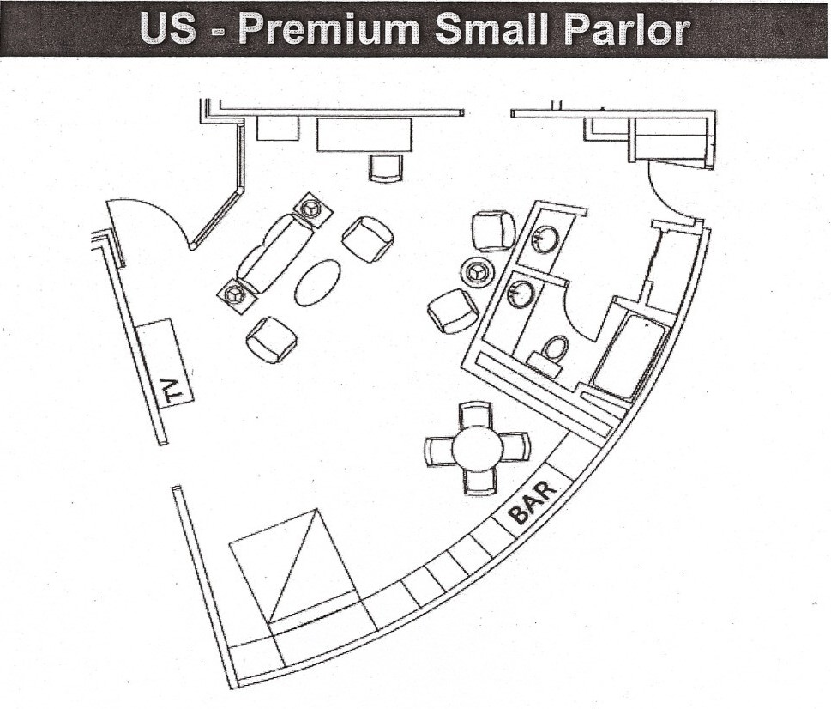

- Parlor Approximately <600 Square Feet
- Table Seats 4-6
- Small Wet Bar
- Connects To One Bedroom & Option For Second
- Meeting Capacity 25 PPL Flowing

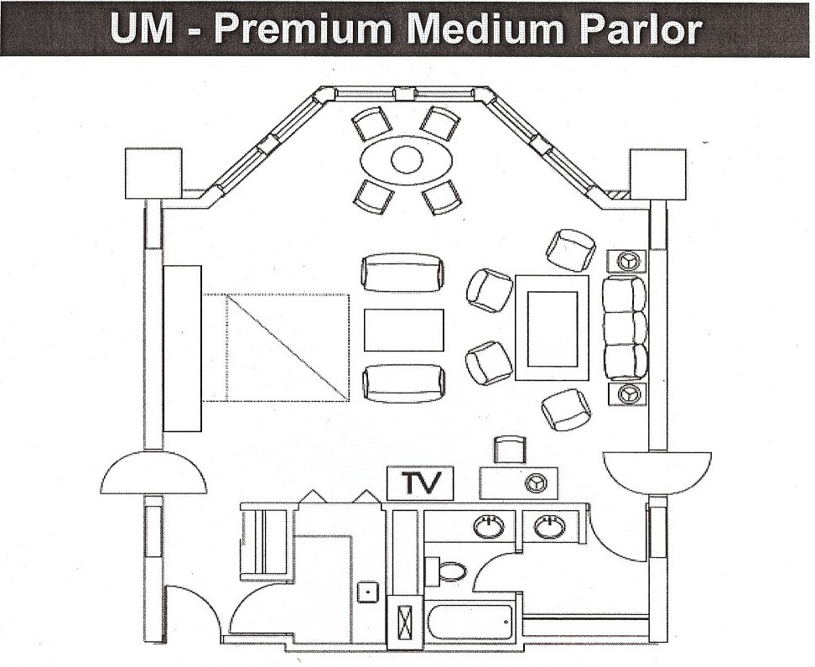

- Suite Approximately 600-1,000 Square Feet
- Table Seats 4-8
- Separate Wet Bar
- Connects To One Bedroom & Option for Second Bedroom
- Meeting Capacity 40 PPL Flowing

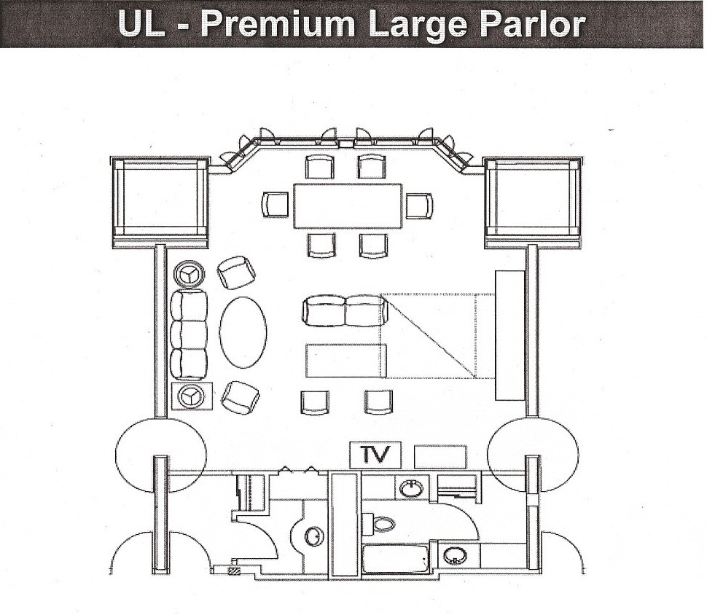
- Suite Approximately >1,000 square feet
- Table That Seats 4-8
- Wet Bar
- Connects To One Bedroom & Option for 2nd Bedroom
- Meeting Capacity 50 PPL Flowing



Daily News
Exciting Times! … Monday …. . September 1 0, 2022
0630-0730 5K Fun Run (Rancho San Raphael)
0630-0930 *Breakfast (Arkansas Hospitality Room)
0800-0900 Professional Development (Convention Center C4)
0800-1200 Resolutions Committee (Army) (Convention Center E2) 0800-1200 Resolutions Committee (Air) (Convention Center E3)
0900-1100 Area IV Meeting/Caucuses (Convention Center F5)
(OPD attendees are encouraged to attend Area IV events)
1030-1200 1130-1300
Company Grade Professional Development/Brunch (Convention Center C4)
(Other OPD attendees visit exhibits — Exhibit Hall 1,2,3) Light lunch/snacks (Arkansas Hospitality Room)
1200-1700 First Business Session (Exhibit Hall 4,5) Hotel pickup for Governor’s Reception
(Meet in Arkansas Hospitality Room at 1730 hours)
1800-2300
Governor’s Reception (Reno Aces Baseball Stadium)
2100-2300 Bus transportation to hotels
*Menu attached
Attire:
Meetings/Business Session: Military Class B/Civilian Business Casual Governor’s Reception: Civilian Casual/Conference Shirts
Exhibition Hall hours: 1030-1700 hours
(Ribbon Cutting ceremony at 1030 hours)

Menu



Arkansas Hospitality Room
Breakfast 6:30 a.m. — 9:30 a.m.
Breakfast Croissant Sandwich Station
Fresh baked butter croissants
Scrambled eggs
Diced ham
Breakfast potatoes
Fresh sliced fruit
Coffee
Juice
Water

11:30 a.m.— 1:00 p.m.
Light Lunch/Snacks

Dear ______:
We are making plans for the 2025 National Guard Association of the United States General Conference to be conducted in Milwaukee, WI, in August. Our association will be well represented with approximately _ members and guests making up the (state) delegation. We will host a hospitality room for our members and open it to other state associations as well. In addition, we will participate as one of seven states sponsoring a special hospitality event to help strengthen the bonds among the other associations.
These events are costly, and any monetary support your organization can provide to help defray our expense of approximately $ ___will be greatly appreciated and will add significantly to the enjoyment of the activities. Your company’s generosity will be recognized and exhibited throughout the conference.
A postage-paid envelope is enclosed for your convenience, and we thank you in advance for whatever you can do. If we can provide additional information, please contact our office at or e-mail .
Thank you again for your support.
Kindest regards,
Executive Director

